**Terminal**

Reference: http://www.airspayce.com/mikem/bcm2835/

|  |
| --- |
| wget http://www.airspayce.com/mikem/bcm2835/bcm2835-1.63.tar.gz  tar zxvf bcm2835-1.63.tar.gz  cd bcm2835-1.63  ./configure  make  sudo make check  sudo make install  cd  sudo npm install –unsafe-perm -g node-dht-sensor  sudo npm install –unsafe-perm -g node-red-contrib-dht-sensor |

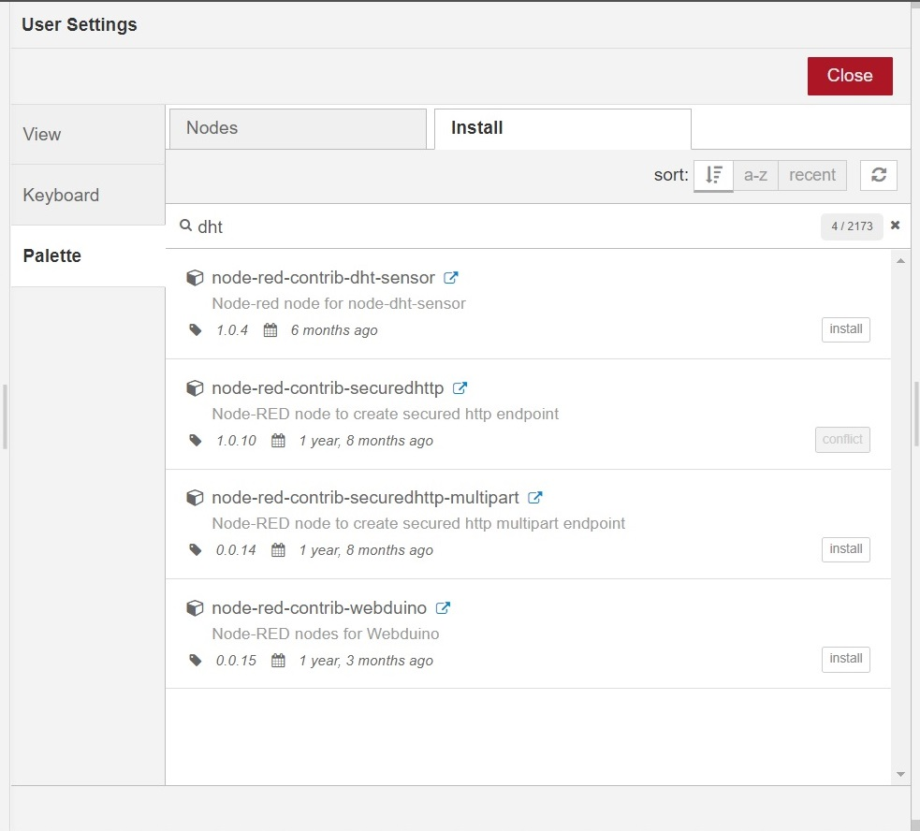

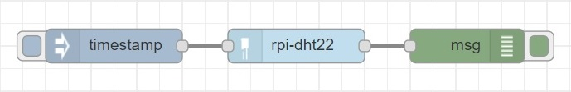

|  |
| --- |
| [{"id":"4c90cf21.cd003","type":"inject","z":"9741cb89.aaf998","name":"","topic":"","payload":"","payloadType":"date","repeat":"","crontab":"","once":false,"onceDelay":0.1,"x":268,"y":234,"wires":[["2da0658b.ed031a"]]},{"id":"a4bd8f55.0fb6c","type":"debug","z":"9741cb89.aaf998","name":"","active":true,"tosidebar":true,"console":false,"tostatus":false,"complete":"true","targetType":"full","x":578,"y":234,"wires":[]},{"id":"2da0658b.ed031a","type":"rpi-dht22","z":"9741cb89.aaf998","name":"","topic":"rpi-dht22","dht":22,"pintype":"0","pin":"4","x":428,"y":234,"wires":[["a4bd8f55.0fb6c"]]}] |

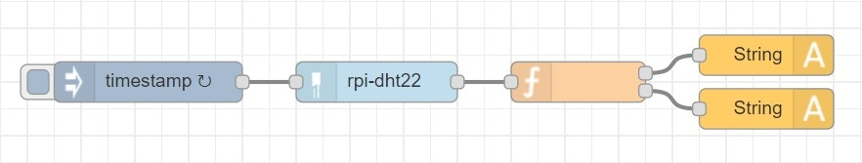

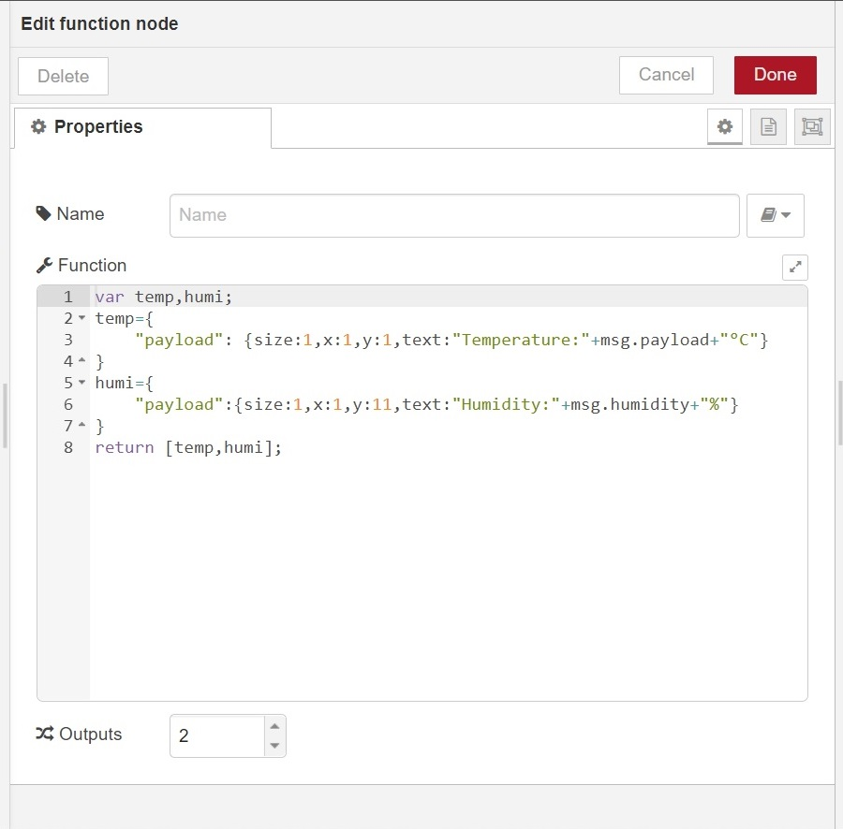

|  |
| --- |
| [{"id":"a07ba111.d28fd","type":"inject","z":"c342db9f.d90f88","name":"","topic":"","payload":"","payloadType":"date","repeat":"1","crontab":"","once":false,"onceDelay":0.1,"x":210,"y":160,"wires":[["d32ae966.faa408"]]},{"id":"d32ae966.faa408","type":"rpi-dht22","z":"c342db9f.d90f88","name":"","topic":"rpi-dht22","dht":22,"pintype":"0","pin":"23","x":380,"y":160,"wires":[["69e86eb6.63e77"]]},{"id":"69e86eb6.63e77","type":"function","z":"c342db9f.d90f88","name":"","func":"var temp,humi;\ntemp={\n \"payload\": {size:1,x:1,y:1,text:\"Temperature:\"+msg.payload+\"°C\"}\n}\nhumi={\n \"payload\":{size:1,x:1,y:11,text:\"Humidity:\"+msg.humidity+\"%\"}\n}\nreturn [temp,humi];","outputs":2,"noerr":0,"x":530,"y":160,"wires":[["360732db.669a5e"],["66ff11d9.ed344"]]},{"id":"360732db.669a5e","type":"String","z":"c342db9f.d90f88","name":"","display":"3129882c.288d78","x":670,"y":140,"wires":[]},{"id":"66ff11d9.ed344","type":"String","z":"c342db9f.d90f88","name":"","display":"3129882c.288d78","x":670,"y":180,"wires":[]},{"id":"3129882c.288d78","type":"oled-config","z":"","name":"OLED","width":"128","height":"64","address":"3c"}] |